Ticketing App – User manual

Contents

User Manual 3

Administrator Manual 4

First time setup 4

Configuration 4

Deploying the application using IIS 4

Developer manual 10

# User Manual

In order to get a ticket for a service, click the button for that service.

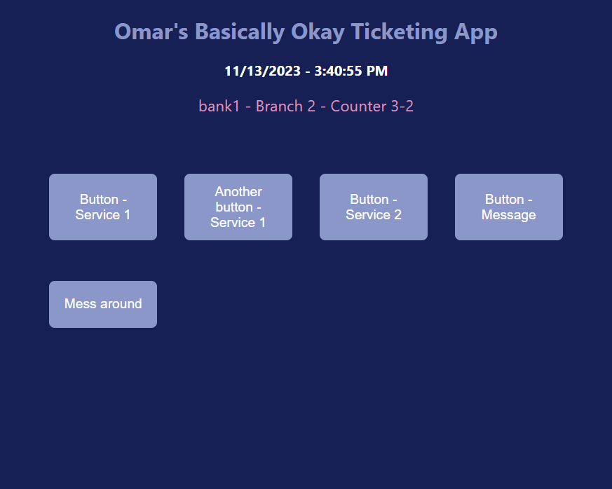

You should then get a confirmation message.

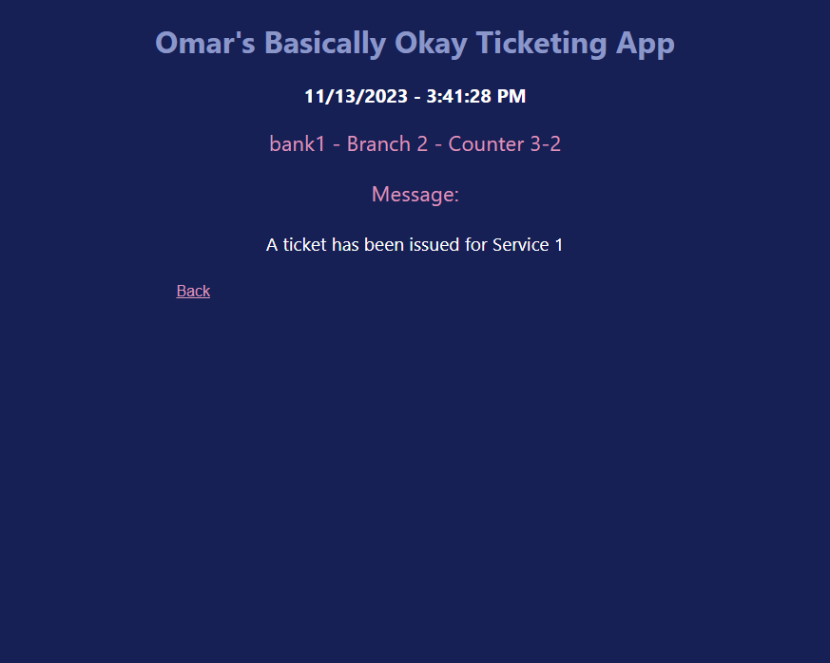

# Administrator Manual

## First time setup

### Configuration

To configure the application, open "index.js" in your preferred text editor.

Modify the variables at the top of the file with the desired values.

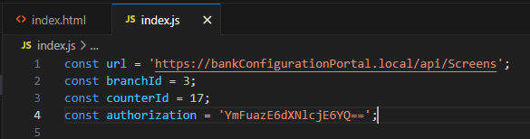

### Deploying the application using IIS

#### IIS Installation

In order to deploy the application, you need to have Internet Information Services (IIS) installed on your machine. Follow the steps below to install it. Note that you need administrator permissions to install IIS.

1. Open the start menu and search for "Turn Windows features on or off".

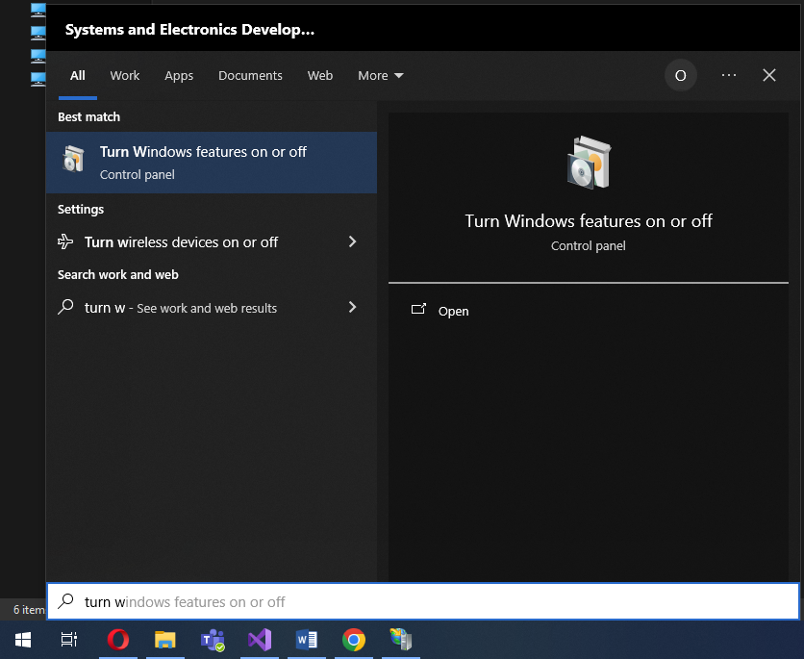

1. Once the window is open, scroll down to "Internet Information Services" and expand it using the + sign.

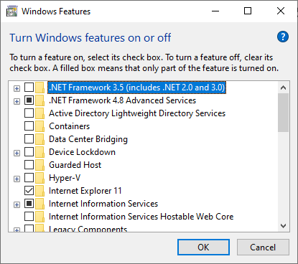

1. Expand "Web Management Tools", and make sure "IIS Management Console" is checked.

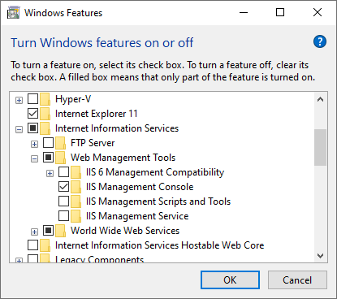

1. Expand "World Wide Web Services" then expand "Common HTTP features".

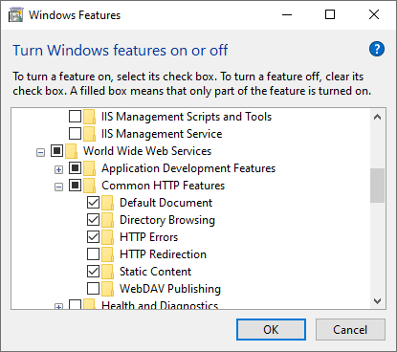

1. Make sure that "Default Document", "Directory Browsing", "HTTP Errors" and "Static Content" are checked.

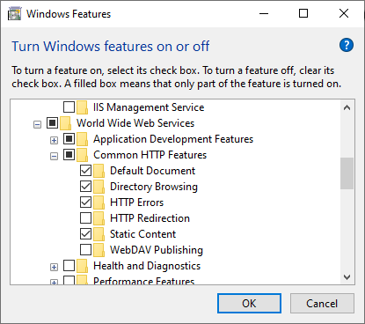

1. Expand "Application Development Features" and make sure ".NET Extensibility 4.8" and "ASP.NET 4.8" are checked.

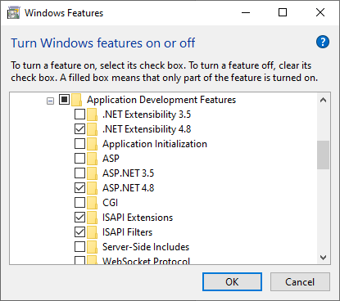

1. Click "OK", and wait for Windows to install the features. If prompted, reboot your machine.

#### Deployment

1. Copy the folder named "Ticketing App" into "C:\inetpub\wwwroot".
2. Open IIS Manager and expand your localhost entry in the "Connections" panel.

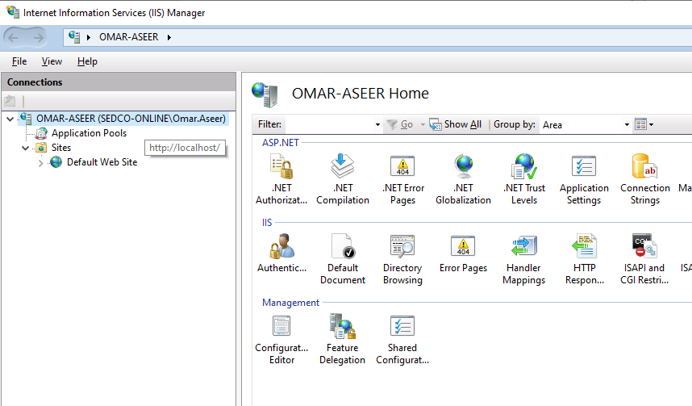

1. Right-click "Sites", and click "Add Website…".

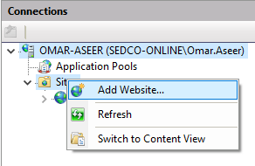

1. Type in the name of the application in the form, then click on the ellipses (…) next to the "Physical path" text box.

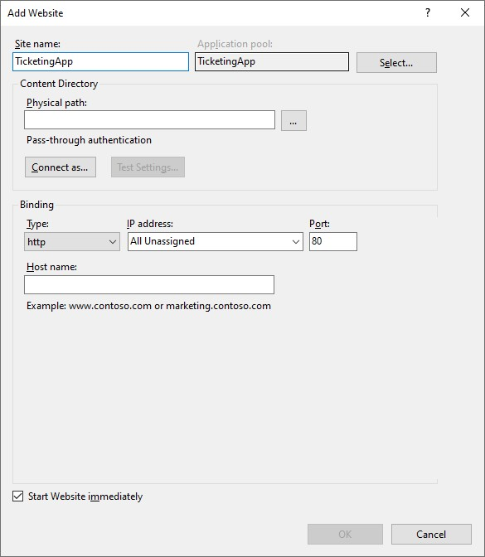

1. Browse for the folder named "Ticketing App" and select it, then click "OK".

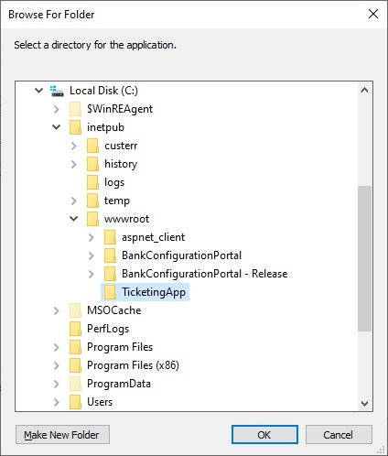

1. Choose a port for the website. Port 80 is usually taken as the port for the default website in IIS, so this example chooses port 90.

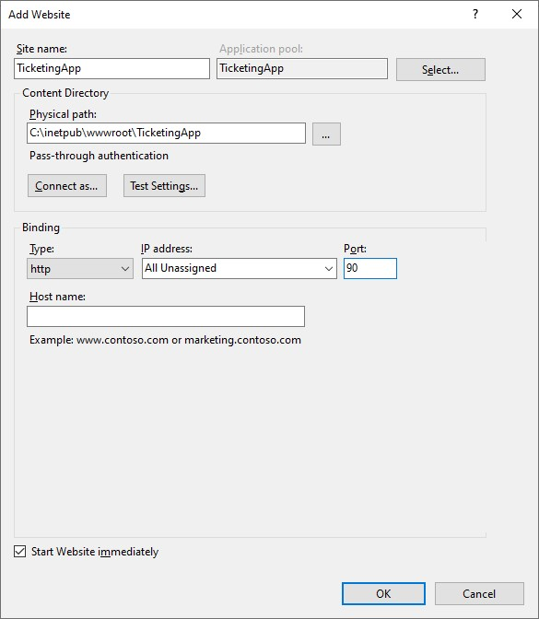

1. Click "OK".



# Developer manual